Fossils: Teacher Background Information
The background information is being provided so that you feel comfortable teaching the Fossils lessons. The following information is just a fraction of what is available in books and on the internet (see the references list). We encourage you and your students to do additional research on the fascinating world of fossils.

Remember to give your students time to observe, draw, reflect, write, and discuss throughout the lessons.

Types of fossils and how they are formed
It is important to note that not all dead organisms become fossils.
- What is needed to become a fossil?
1. Time: lots of time! Millions of years.
2. Pressure: this comes from the weight of the layers that have built up on top of the organism
3. No air: oxygen leads to decaying, no air = no decay
4. Minerals
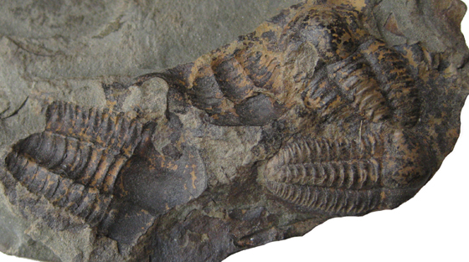
- Fossils come in many forms: not only can fossils be lots of different kinds of plants and animals, they can also be formed in many different ways. No matter how they are formed, they still need to have very special conditions to ever become a fossil.
Mold fossil of a trilobite from http://petrifiedwoodmuseum.org/moldscasts.htm
a. Mold Fossils: The hard part of the fossil (like the shell or bones) dissolves and the mud or sand it was buried and hardens. This leaves a small cavity.

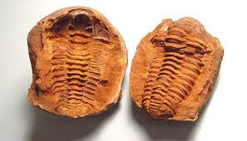
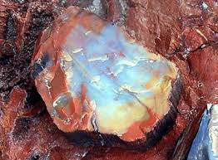
b. Mineralization Fossils: These are formed when the original material that the organism is made of is replaced by minerals. Minerals seep in and replace the hard parts of the organism turning it to stone. Examines of body fossils are petrified wood or bones.
Mold fossil of a trilobite from https://sites.google.com/a/franklincsd.org/middle-school-science/chapter-5-clues-to-earths-past
Petrified Wood from http://geology.com/stories/13/petrified-wood/

c. Cast Fossils: Sometimes the whole cavity of a shell is filled with minerals. This makes a fossil cast of the organism
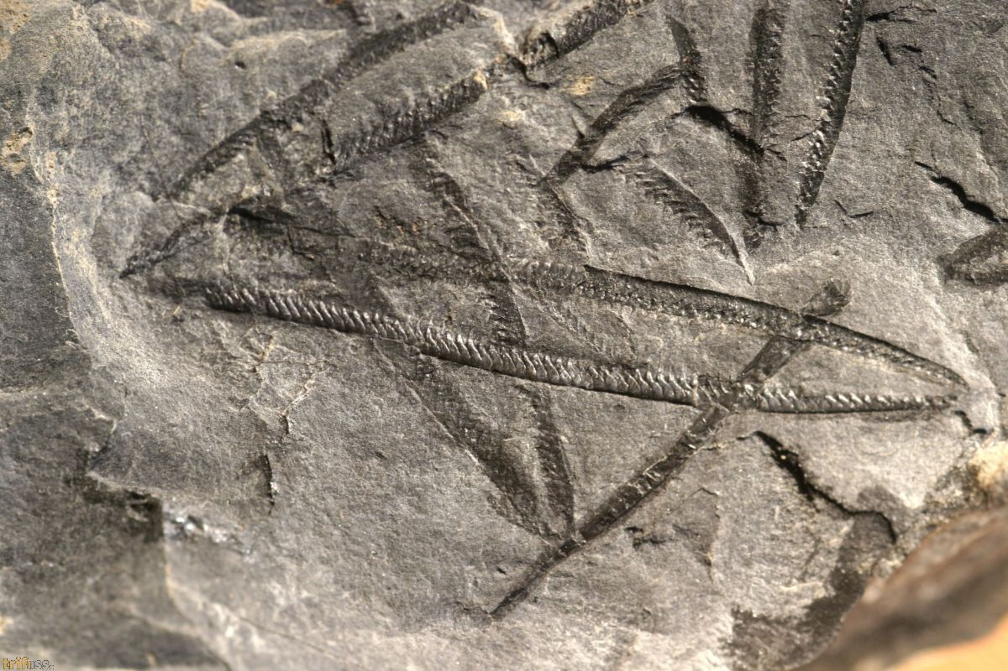
Carbonized fossil of a graptolite from http://trifoss.com/product_info_sold.php?language=en&products_id=1383&
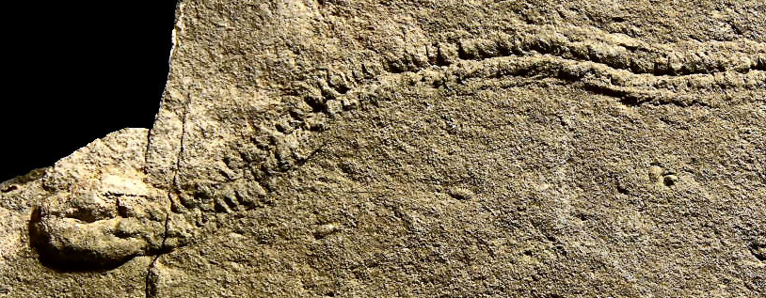
d. Carbon Film Fossils: Some animals but more often leaves are preserved as just a film of carbon on a rock. This film can sometimes leave a little impression in the rock too. The film may get washed away but the impression will remain.
Trace fossils (Cruziana and Rusophycus) of a trilobite from http://www.trilobites.info/trace.htm

e. Trace Fossils: This type of fossil just shows the ‘trace’ of the animal – it represents behavior. Trace fossils can be things like animal burrows or their waste. Trace fossils are not fossils of the actual animal or plant.

